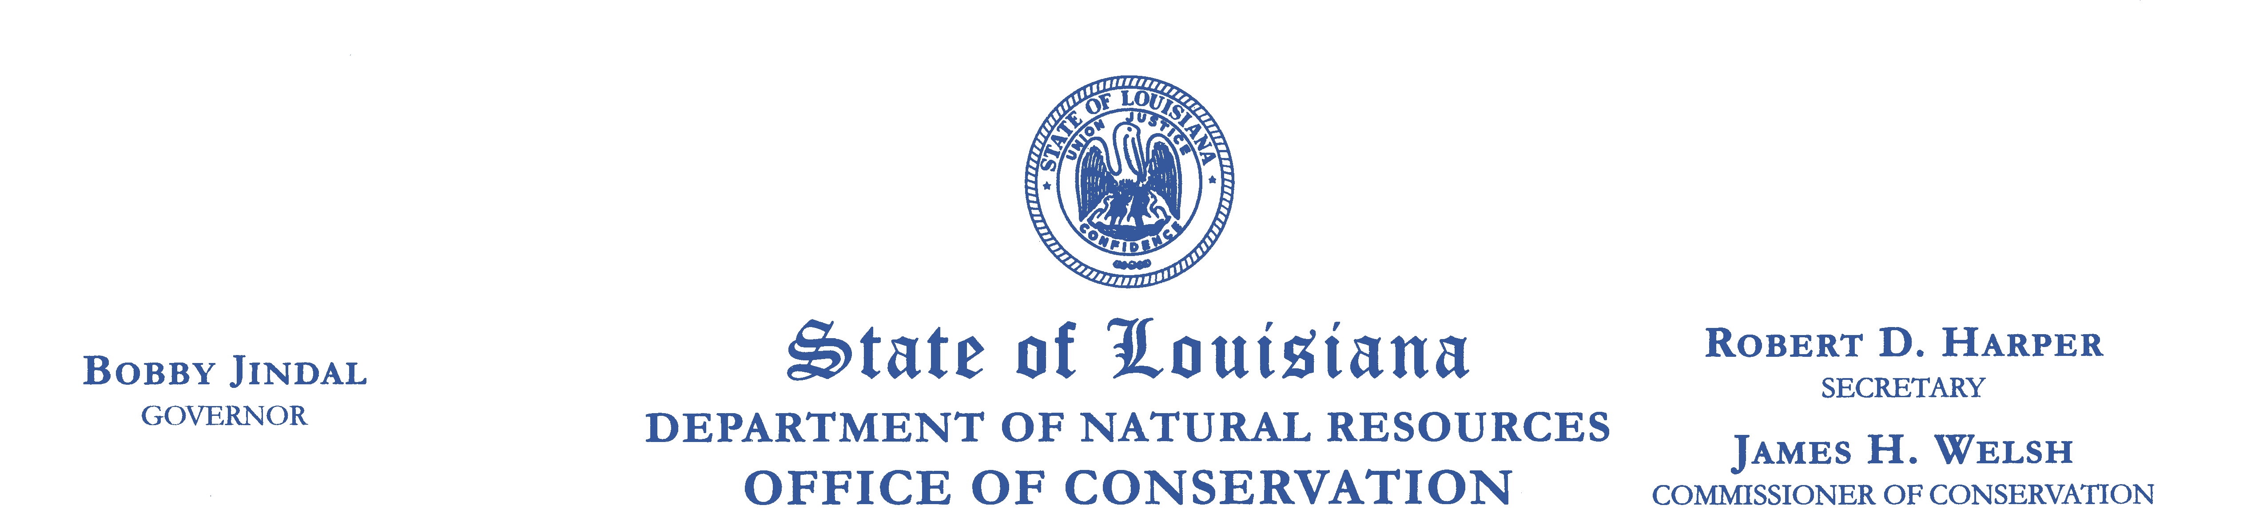

Meeting Notice:
The Ground Water Resources Commission will conduct its
17th Regular Meeting
Wednesday, August 18, 2010
11:00 a.m.
State Capitol
900 North Third Street
House Committee Room 5
Baton Rouge, Louisiana 70802

